FACULTY EVALUATION
Programme Name: Social Entrepreneurship Development Program (SEDP)- Advance Uganda (2nd March 2026 - 6th March 2026)
Session: Establishing Social Impact
Faculty Name: Dr. Cathy Mbidde
No. of Respondents: 21
No. of Participants: 21
Evaluation Parameter | (%) Individual Score | (%) Programme Average
Punctuality (Commencement and Completion of Sessions) | 97 | 91
How well do you understand the core concepts presented? | 96 | 92
Rate your confidence in applying the new skills learnt | 88 | 87
Degree of Faculty preparedness for the sessions | 98 | 97
Content and methodology of the program | 99 | 95
Quality of class and group discussions | 96 | 89
The information presented in the course is relevant to my work (ministry) | 98 | 97
Average scores | 96 | 93

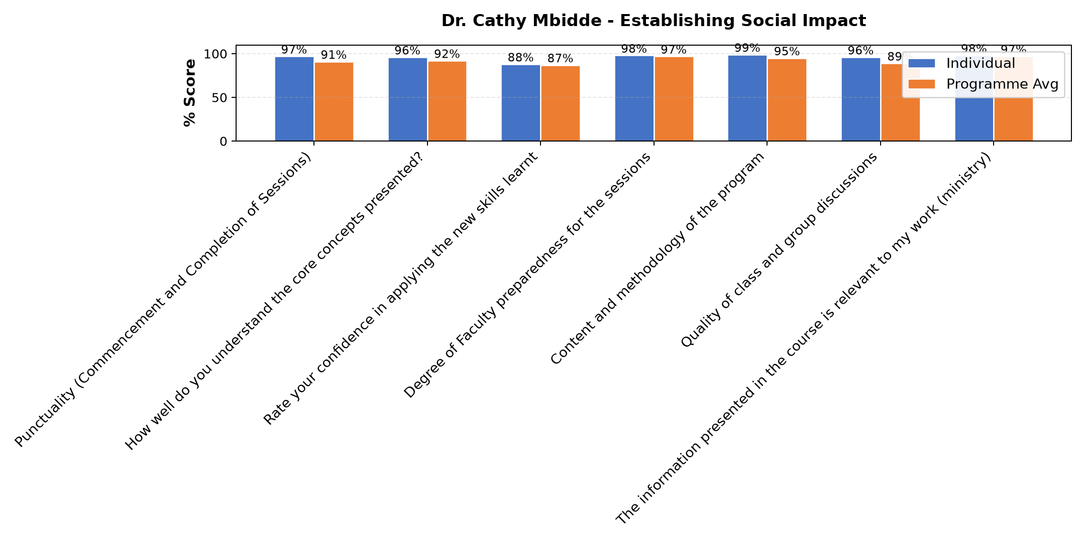

Comments & Feedback
- • She talked alot about social impact it will take time.
- • Language of the People where we are starting the enterprise
- • Good time needed to work with the neighboring community.
- • I will try to put everything into practice though the barriers are there like lack of money,time, follow up.but I will try.
- • funds to expand my social enterprise
- • Finance
- • Being able to truck all the students so that I can measure well the social impact
- • Failing to get time
- • There will be no barriers preventing me from applying what I have learnt.
SUBMITTED THROUGH:
SBS Evaluation Automation System

